1. Create RDD and Print Each Element

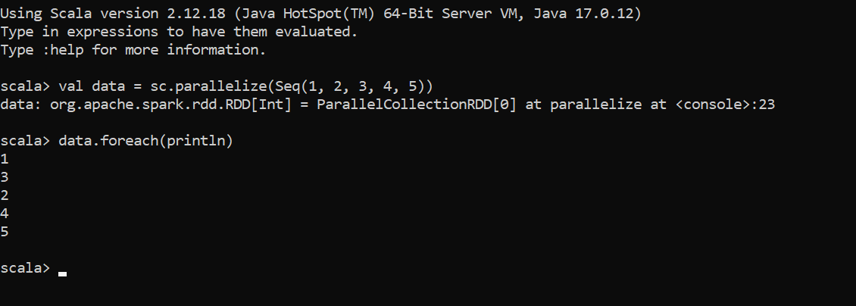

2: Map and Filter on RDD
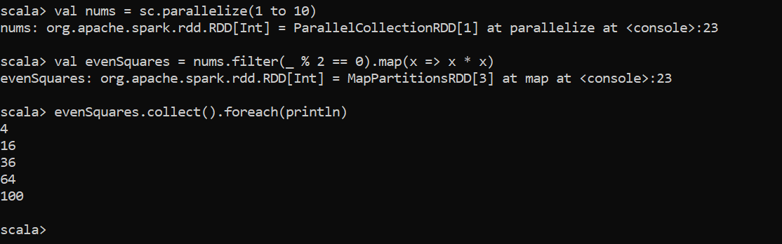

3: Count Words from Text
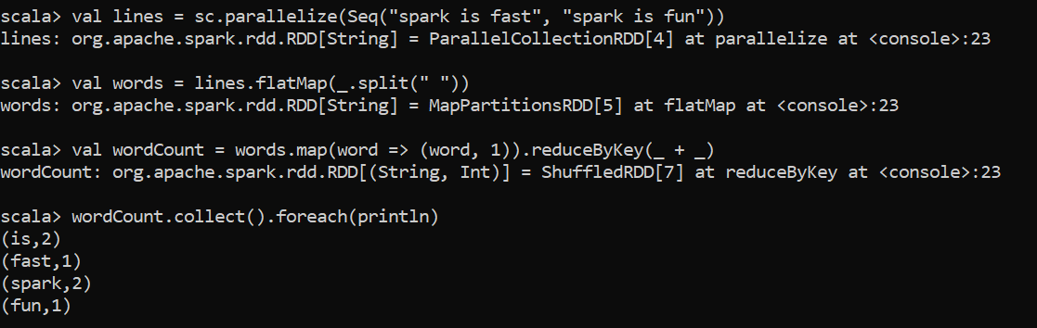

4: Create and Show a Data Frame:
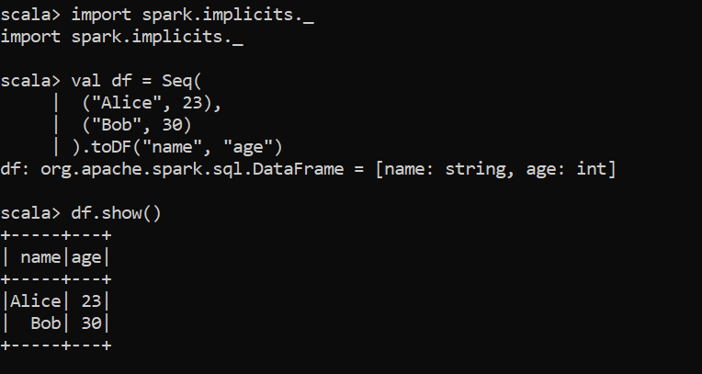

5: Filter Data Frame Rows: 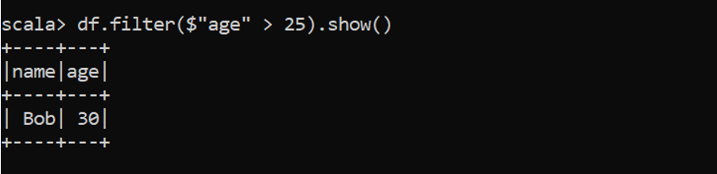

6 . Group By and Aggregate
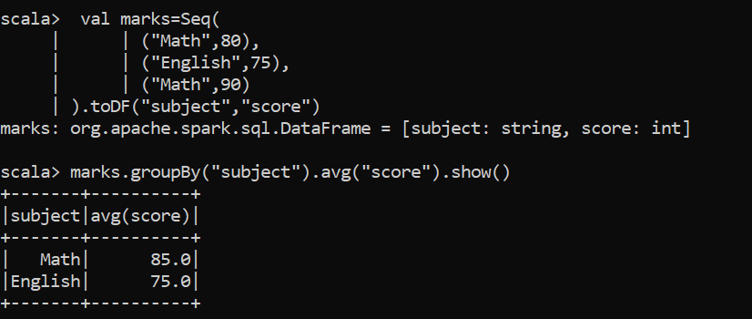

7 . Spark SQL Query
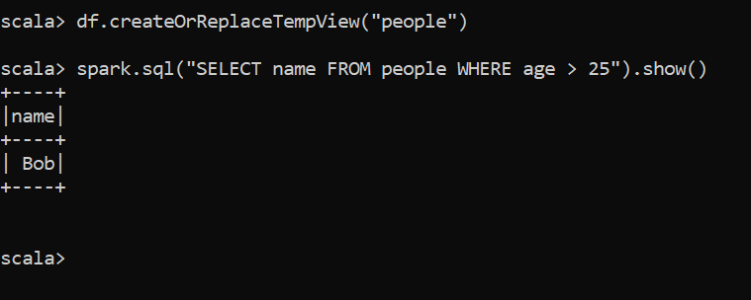

8. Load CSV from File (if available):
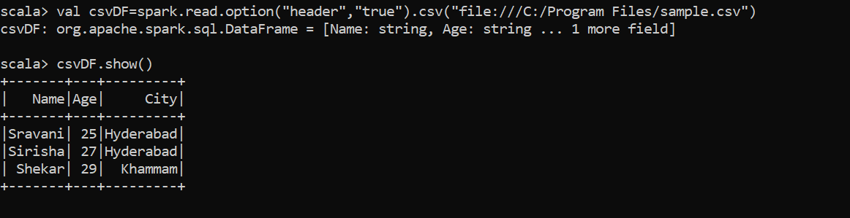

9: Convert Data Frame to RDD
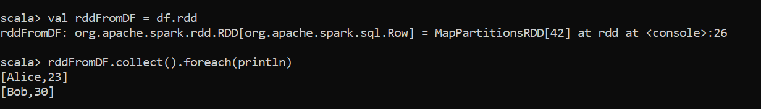

10: Create Dataset with Case Class
